Exercise 1: Homework 1: Dissipative Oscillator
- The IVP code is attached and called “homeworkjosh.c”.

2.
The following plots shows three cases:
A.overdamping 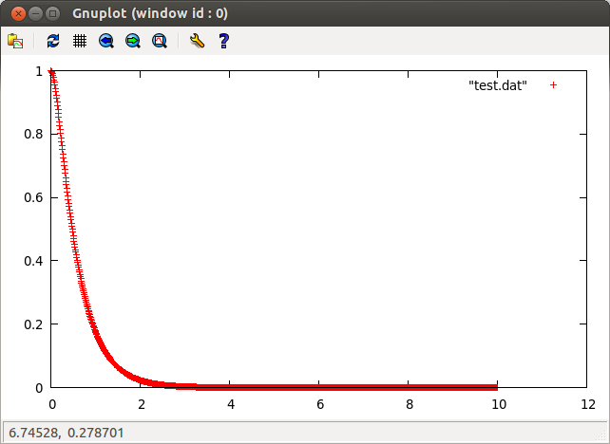
(Beta=5,w0=4)
B. critical damping
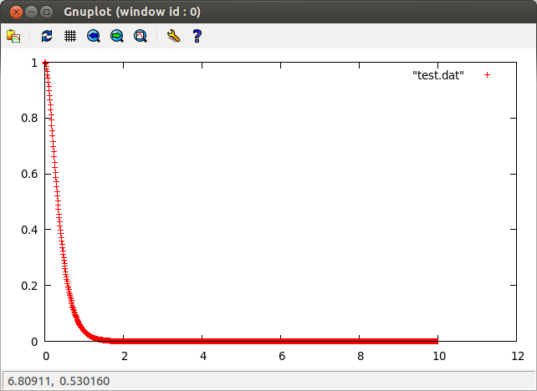
(beta=5,w0=5)

C.underdamping
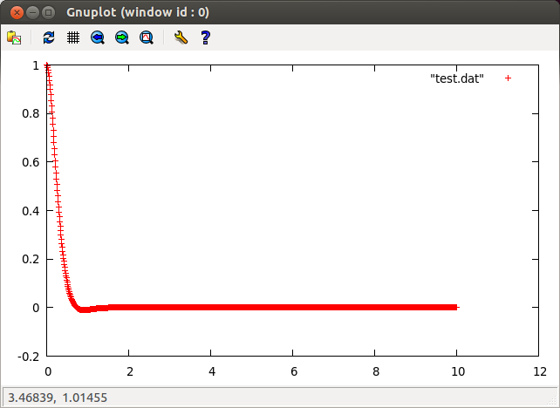
(beta=5,w0=6)

Homework 2: A Real Pendulum
- The IVP code is attached and called “homeworkjosh1.c ”.
- At what value of theta0 does the actual pendulum solution begin to deviate from its small angle approximation?
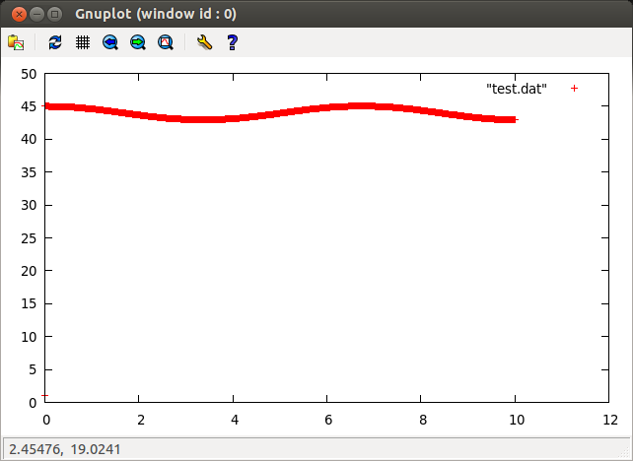
(theta=45)

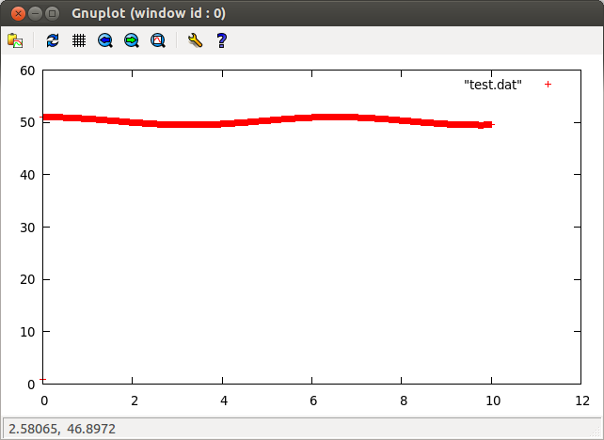
(theta=51)

From the plot graphs, it is clearly that the line of second graph is more flatter than first one. Also, after many trials, the most flat graph can be produced when theta= 51. That is to say, the actual pendulum solution begin to deviate from its small angle approximation when theta= 51.

Exercise 2 homework: Simple Oscillator
1. the analytical solution is y(x)=2sin(x)+cos(x)

2.The bvp code is attached which is called “homeworkjosh2.c”.
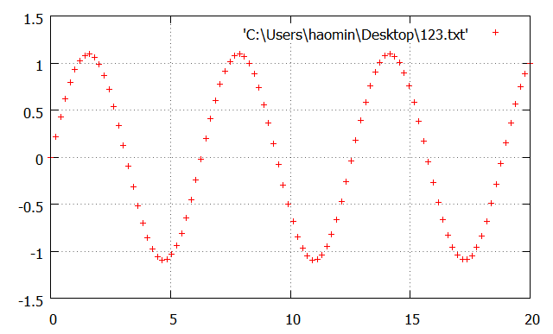
Figure 1.: Minimization function F(s) for the auxiliary IVP.
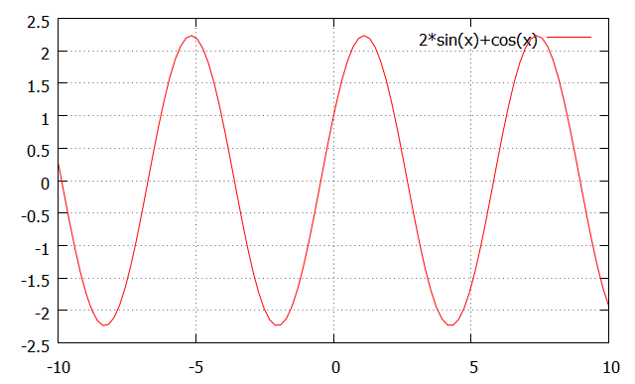
Figure 2.The solution y(t) and its derivative y’(t) satisfying the BVP.

BVP and analytical solution are identical from plots.

